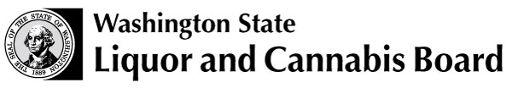 | Licensing and Regulation  1025 Union Ave SE  PO Box 43098  Olympia WA 98504-3098  Phone: 360 664-1600  Fax: 360 753-2710  www.lcb.wa.gov
 |  | License Number
 |  | Trade Name
 |  | UBI Number

ADDED ACTIVITIES FOR DISTILLERIES, BREWERIES AND WINERIES

Added Activities Processing Information
Please answer all the sections of this form that apply to you. Incomplete forms cannot be processed
Submit this form with any additional required documents to the above address.
If you have questions, please call Customer Service at 360-664-1600.

Do you want any of the following activities?
If you answer Yes to any of the activities below, answer all of the questions that apply to your business.
If you answer No to all of the activities, your signature and date is all that is required.

DISTILLERIES, BREWERIES AND WINERIES
Delivery of Alcohol | Yes No
Internet Sales | Yes No
If you checked Yes for Internet Sales, will you be using a third party internet provider? | Yes No
Please list the name of the third party internet provider:

Where will the sale of your products (including alcohol) take place?

How do you plan to deliver the product?

How will you be certain only people 21 or older make the purchase and receive the delivery?

I certify under penalty of perjury under Washington State law that the foregoing is true and correct.

Print Name: |  |  | Date:
Signature: |  |  | Phone: | ( )–( )-( )
Print Title: |  |  | E-mail
(for example, sole proprietor, corporate officer,
partner, LLC manager or member.)

